**Module 1 Assignment – Foundations, Pitch, and Django Practice**

**Student**: Mafruha Chowdhury  
**Course:** CIDM 6325/70 – Electronic Commerce and Web Development  
**Submission Date**: 09/01/2025

**Abstract:**

This submission presents a logistics-focused project under the scope of Electronic Commerce and Web Development. It proposes an **AI-enhanced perishable food supply platform** that optimizes delivery routing, warehouse coordination, and real-time scheduling—built using a Django-based web framework with HTMX and Bootstrap for rapid, user-facing deployment.

The system is designed to minimize spoilage, reduce dispatch delays, and improve service reliability across airline catering, restaurant supply chains, and grocery retail logistics. The deliverable includes a professional memo (2–3 pages), a series of system architecture diagrams, and a heatmapped AI risk registry.

This solution directly addresses inefficiencies in static routing and manual dispatching using a transparent, modular AI integration approach. It aligns with NIST’s AI Risk Management Framework and draws ethical and implementation guidance from IEEE P7003 and ISO 27001-K standards. The architecture is tailored to support rapid MVP delivery while remaining auditable, secure, and stakeholder aware.

TOC:

Module 1 Assignment – Foundations, Pitch, and Django Practice

**Project Overview**

**1. Problem Statement**

2. Domain and Concept Focus

**3. Stakeholders**

**4. Scope and Boundaries**

**5. Success Metrics**

**6. Minimum Viable Artifact (Shippable in 2 Weeks)**

**7. System Sketch**

**8. Evidence Base**

**9. Risk Registry**

**Referenced Standards and Frameworks**

10. AI Risk Governance – Strategic Question Set

**AI Use Disclosure Footnote (GitHub-Linked)**

11. Risk Register Validation Note

Appendix A: System Diagrams

**A.1 System-Level Architecture Diagram**

**A.2 UML Class Diagram (Model-Level)**

**A.3 Data Flow Diagram (DFD – Level 1)**

**A.4 Component Architecture Diagram**

**Diagram Versioning Note**

**Project Overview**

**Title**: *AI-Enhanced Perishable Food Supply Platform for Regional Distribution and Airline Catering*

This platform will streamline the distribution of time-sensitive food products (fresh produce, bakery, and catering supplies) from regional hubs to various client endpoints—grocery stores, restaurants, and airlines. Leveraging AI for route optimization, real-time inventory checks, and predictive delivery adjustments, the system aims to reduce spoilage, increase operational transparency, and enhance service reliability.

**1. Problem Statement**

Current perishable food logistics suffer from:

* Delayed routing decisions and static scheduling
* Poor visibility into real-time delivery status
* High spoilage rates due to suboptimal warehousing or route failures
* Inability to flexibly adapt to airline or catering delivery shifts

Despite some digitization, many mid-tier logistics players still operate on outdated, rule-based scheduling systems without AI augmentation. This leads to inefficiencies in matching supply with real-time demand.

**2. Domain and Concept Focus**

**Domain**: AI-augmented logistics for perishable food distribution and regional supply chain coordination.

**Concept Focus**: AI-Augmented Routing — Integrating real-time AI-driven route optimization into short-window delivery operations to reduce spoilage, maintain freshness, and ensure just-in-time inventory handoff.

**Core Challenge Exposed**: Traditional logistics systems lack adaptability and real-time decision-making, resulting in high spoilage rates, delayed dispatches, and inefficiencies across regional hubs. The absence of AI-driven insight limits responsiveness to dynamic delivery constraints, especially for high-risk perishables and time-sensitive airline or catering contracts.

**3. Stakeholders**

* **Internal**: Logistics Operators, AI Engineers, Warehouse Managers, Customer Support Team
* **External**: Food suppliers, Airline Catering Teams, Restaurant Managers, Compliance Auditors
* **Overlapping**: Third-party Delivery Partners, Regional Hub Supervisors, Food Safety Inspectors

**4. Scope and Boundaries**

**In Scope**:

* Regional distribution from warehouses to client endpoints
* AI-assisted scheduling, routing, and real-time ETA predictions
* Dashboard and notification features for end-users

**Out of Scope**:

* Global supply chain management (outside regional US)
* AI-based demand forecasting at the source-supplier level
* Inventory procurement logic from farms

**5. Success Metrics**

* ≥ 20% reduction in spoilage or wastage within 6 months of deployment
* ≥ 30% improvement in on-time delivery rates
* Reduction of human dispatch intervention by ≥ 50%
* User satisfaction (Net Promoter Score ≥ 8/10 after 3 months)

**6. Minimum Viable Artifact (Shippable in 2 Weeks)**

A basic **Django-based web platform** that allows:

* Manual input of incoming food shipments
* AI-generated delivery schedules using mock location and inventory data
* Real-time driver ETA simulation via a dashboard
* Front-end: Bootstrap/HTMX; Backend: Django + SQLite

📂 A fully functional Django-based implementation of this MVP is available at:  
[**GitHub – CIDM632570 Module2Assignment Repo**](https://github.com/Mafruha17/CIDM632570/tree/Module2Assignment/Module2Assignment),  
featuring HTMX-enhanced forms, Bootstrap-styled interfaces, Django Admin integration, and mock AI-generated ETA logic.

**7. System Sketch**

We'll include a labeled block diagram highlighting:

* Front-end: Ordering Interface
* AI Layer: Route Optimizer, Inventory Sync, ETA Predictor
* Back-end: Django server, database layer, and regional warehouse API simulation
* Clients: Grocery chain, Airline catering, Local restaurant

(Diagram to follow—can be sketched separately)

**8. Evidence Base**

Cited sources will include:

* [McKinsey Report] on AI in food logistics (2024)
* [NIST AI RMF] for AI risk governance alignment
* [IEEE Supply Chain Standards] on traceability and reliability

### **9. Risk Registry**

Risk Severity column, using red, yellow, and green scale based on Impact + Likelihood

|  |  |  |
| --- | --- | --- |
| **Severity** | **Color** | **Meaning** |
| High | 🔴 Red | Significant impact and high likelihood |
| Medium | 🟡 Yellow | Moderate impact or mitigated likelihood |
| Low | 🟢 Green | Minor impact, well-controlled |

|  |  |  |
| --- | --- | --- |
| **Risk** | **Impact** | **Mitigation** |
| Route prediction failure | Delays deliveries | AI fallback to static route rules |
| Data inaccuracies | Inventory mismatches | Regular data validation pipeline |
| Ethical bias in routing | Service disparity | Use diverse dataset + audit logs |

AI Risk Registry (with Heatmap)

|  |  |  |  |  |  |
| --- | --- | --- | --- | --- | --- |
| **#** | **Risk Category** | **Specific Concern** | **Impact** | **Mitigation Strategy** | **Severity** |
| 1 | **Model Reliability** | AI-generated routes and ETAs may rely on outdated, biased, or incomplete data | Inaccurate delivery timing, increased spoilage, broken SLAs | Validate against historical data; fallback to rule-based routing when AI confidence is low | 🔴 High |
| 2 | **Algorithmic Bias** | Routes may favor high-profit clients, disadvantaging smaller or rural customers | Service inequality, regulatory scrutiny, reputational damage | Enforce fairness rules in route optimizer; perform regular audits of delivery patterns | 🟡 Medium |
| 3 | **Data Privacy & Security** | Sensitive inventory and customer metadata may be exposed or misused | Breach of privacy obligations, legal penalties, loss of stakeholder trust | Apply RBAC, data encryption, NIST-aligned security protocols (800-53, ISO 27001-K) | 🔴 High |
| 4 | **Explainability & Transparency** | AI logic may be opaque to stakeholders and operators | Operational resistance, loss of confidence in automated decisions | Provide rationale for routing logic; log AI decisions and input/output for traceability | 🟡 Medium |
| 5 | **Over-Automation Ethics** | Fully automated routing may bypass dispatcher oversight or reduce human roles | Labor friction, ethical concerns on human replacement | Maintain human-in-the-loop; use AI to assist—not replace—dispatch roles during MVP phase | 🟢 Low |
| 6 | **Vendor Lock-In** | Over-reliance on third-party AI tools (e.g., proprietary APIs for routing) | IP entanglement, cost scaling issues, loss of architectural flexibility | Use modular abstraction layers; prefer open-source where feasible | 🟡 Medium |
| 7 | **Governance & Lifecycle Control** | Lack of structured AI oversight mechanisms throughout iterations | Poor accountability, untracked risk evolution, failure in audits | Align with NIST AI RMF; maintain internal AI Risk Registry per sprint or release | 🔴 High |

### **Referenced Standards and Frameworks**

* **NIST AI RMF 1.0** (2023)– Governance Framework for AI system risk lifecycle
* **IEEE P7003** – Fairness and bias auditing in AI systems
* **ISO/IEC 27001-K** – Data security controls (technical and procedural) | Information Security Management controls
* **HIPAA / NDA Terms** – For sensitive delivery contexts (e.g., medical catering) Applicable for airline or medical food delivery chains

**10. AI Risk Governance – Strategic Question Set**

This section identifies guiding questions designed to align the platform’s AI components with responsible governance practices. Drawing from the NIST AI Risk Management Framework (RMF), these questions are intended to guide future decisions related to risk control, transparency, and lifecycle oversight.

**Strategic Questions:**

1. Has the AI-driven route optimization logic been reviewed for fairness across different customer tiers and locations?
2. What traceability mechanisms are in place to audit decisions made by the AI engine (e.g., ETA predictions, route changes)?
3. How is stakeholder feedback (e.g., warehouse staff, dispatchers) incorporated into iterative AI model improvements?
4. What fallback controls exist in the event of AI malfunction or erroneous predictions?
5. Who is accountable for AI oversight during the MVP phase, and how will this change as the system scales?
6. Are data collection practices (for routes, delivery times, warehouse status) compliant with internal policies and external standards?
7. Does the organization have a formal review cadence (weekly/monthly) to evaluate AI performance metrics and risks?

**AI Use Disclosure**

Note: All AI-related logic (route generation, ETA prediction) is transparently coded and logged for traceability. AI does not make autonomous decisions without human review during the MVP stage.

**AI Use Disclosure Footnote (GitHub-Linked)**

**AI Implementation Transparency Note:**  
All AI-related logic—including mock ETA generation and routing placeholders—is implemented transparently within the Django codebase. The source code is available for audit at:  
[github.com/Mafruha17/CIDM632570/tree/Module2Assignment/Module2Assignment](https://github.com/Mafruha17/CIDM632570/tree/Module2Assignment/Module2Assignment)

**11. Risk Register Validation Note**

The AI Risk Registry included in this submission was developed in alignment with the NIST AI Risk Management Framework (AI RMF 1.0, 2023) and reviewed against early-stage project requirements. The severity assignments reflect the impact-likelihood matrix based on initial use-case scoping and are expected to evolve.

**Validation Notes:**

* Risks were evaluated considering both ethical and operational failure points.
* The team assumes MVP-stage safeguards will include manual overrides and human-in-the-loop constraints.
* This risk registry will be updated iteratively during future implementation phases (e.g., Part D/H) as new data sources, APIs, or compliance obligations emerge.

**12. Conclusion**

This project addresses a high-impact logistics problem using an AI-native architecture aligned with modern ethical, traceability, and efficiency standards. It is scoped realistically to deliver a working MVP in 2 weeks, with tangible outcomes and scalable architecture for future iterations.

**Appendix A: System Diagrams**

This appendix contains four diagrams that illustrate the AI-enhanced perishable food logistics platform’s architecture. Each diagram addresses a different layer of the system—from high-level interactions to deployment-level components.

**A.1 System-Level Architecture Diagram**

**Purpose**: Illustrates the end-to-end interaction among users, AI systems, Django backend, and external data sources (e.g., warehouse APIs).

*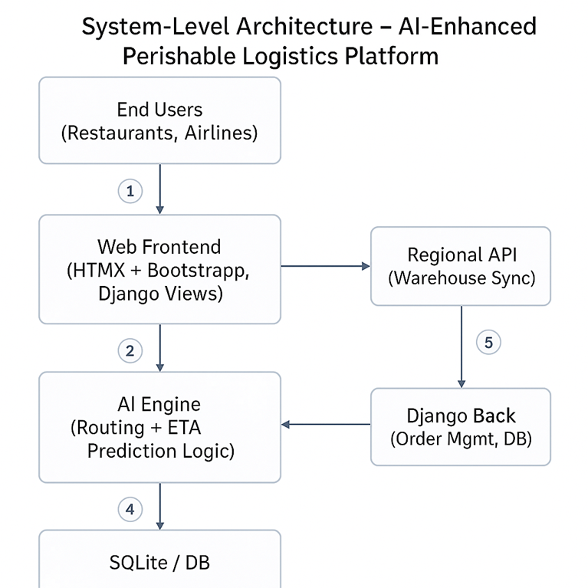:*

*System-Level Architecture – AI-Enhanced Perishable Logistics Platform*

**A.2 UML Class Diagram (Model-Level)**

**Purpose**: Maps the primary Django model relationships such as User, Order, Delivery, Inventory, and Route.

*Diagram: UML Class Diagram – Core Models*

**A.3 Data Flow Diagram (DFD – Level 1)**

**Purpose**: Illustrates how data flows from the user through the Django app to the AI engine, and into persistence/storage layers.

*Diagram: DFD – AI Decision Flow in Logistics Platform*

**A.4 Component Architecture Diagram**

*Diagram: Component Architecture – Deployment View*

**Purpose**: Details the tech stack and how system components interact during runtime.

**Diagram Versioning Note**

All diagrams reflect the initial MVP architecture planned for the 2-week shippable scope. Updates may occur in future modules (e.g., Part D or Part H) based on revised AI logic, API integration, or front-end requirements.